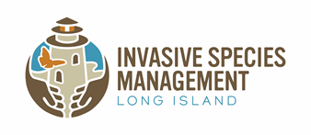
Long Island Invasive Species Management Area (LIISMA)
Partners Meeting & Workshop

Date: September 5, 2025 Time: 10:00 A.M. – 1:00 P.M.
Location: The Sisters of Saint Joseph, Building 4, La Providencia Dining Room, 1725 Brentwood Road, 11717

RSVP for In-Person Attendance: LIISMA Fall Partners Meeting & Workshop - Long Island Invasive Species Management Area (LIISMA)
Register for Zoom Attendance: Meeting Registration - Zoom

10:00 - 10:15 a.m. | Welcome and LIISMA update
10:15 - 10:30 a.m. | Partner Spotlight: North Shore Land Alliance with Darcy McDowell “ Restoration in Progress: The Ever-Evolving Management of Mugwort (Artemisia vulgaris) in the Humes Preserve Meadow.”
10:30 - 10:45 a.m. | Roundtable Announcements
10:45 - 11:00 a.m. | Break
11:00 a.m. - 12:00 p.m. | Rich Ring, “Rare plants of Long Island and the invasive species threatening them.”
12:00 - 1:00 p.m. | Katherine Lawson, “Marine Invasive Species: Biofouling Vectors, Prevention, and Spread of Marine Invertebrates”
1:00 p.m. | Other business and wrap up

